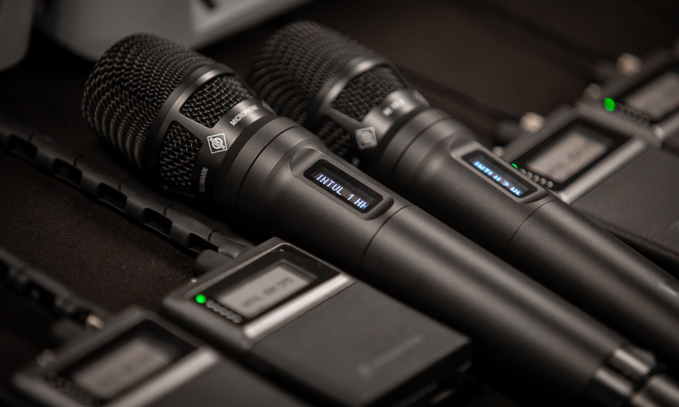

Sennheiser’s Spectera SKM handheld transmitter is now shipping
Spectera SKM completes the core elements of the Spectera wideband wireless ecosystem

Wedemark/Amsterdam, 10 September 2026 – Sennheiser has started shipping the Spectera SKM handheld transmitter, completing the core elements of the audio specialist’s bidirectional wideband wireless ecosystem. Designed for professional live sound, theatre, broadcast and places of worship applications, the SKM brings premium handheld microphone performance to the Spectera system.

Powered by Sennheiser’s WMAS approach, Spectera addresses many of the typical challenges that users, operators and owners of wireless audio systems experience today. The Spectera SKM combines Sennheiser’s renowned sound quality with the flexibility and control of the Spectera ecosystem. It delivers ultra-low-latency wireless audio while providing the continuous monitoring, remote configuration and operational visibility required by today’s productions.

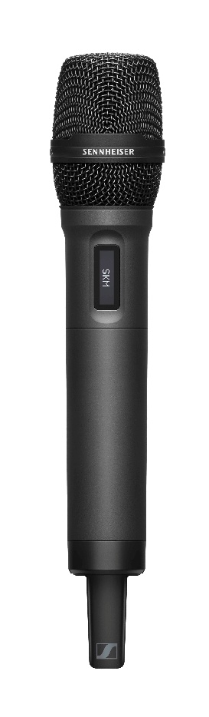
All monitor and control data use the same RF wideband channel as the audio data, a separate wireless control network is not required. The Spectera handheld transmitter maintains continuous bidirectional communication with the Base Station, enabling engineers to monitor battery status, RF performance, audio levels, signal strength and link quality in real time while remotely adjusting key microphone parameters such as gain and low-cut.

The Spectera SKM combines Sennheiser’s renowned sound quality with the flexibility and control of the Spectera ecosystem.

“We are excited to have started shipping the SKM handheld, completing the core elements of our Spectera system”, says Bernd Neubauer, Product Manager at Sennheiser. “At the same time, we will continue evolving the ecosystem based on industry feedback, needs and ideas. Over time, Spectera will be expanded with new software features, hardware devices and services.”

Professional wireless. Without the complexity.
Available in both UHF and 1.4 GHz variants, the handheld delivers ultra-low latency down to 1.0 ms. The Spectera SKM takes full advantage of Sennheiser’s wideband WMAS technology: instead of adding an individual receiver channel and coordinating a separate narrowband frequency for each additional handheld, engineers can add the SKM as another device within the Spectera wideband RF environment. This helps simplify RF planning, improves resilience to RF fading and gives production teams greater confidence when deploying wireless microphones in demanding spectrum environments.

The SKM handheld shares the BA 70 or BA 70 2.2 rechargeable battery with the Spectera SEK bodypack and features robust metal construction, AES-256 encryption and an OLED display.
Compatible with a wide range of Sennheiser and Neumann microphone capsules, including the all-new Neumann KK 104 A and KK 105 A capsule heads, the Spectera SKM handheld can be tailored to suit a wide range of voices, applications and performance styles while maintaining the natural, detailed sound quality associated with Sennheiser microphones.

[Ends]

Technical Data
System
Transmission scheme: Multicarrier, TDMA, TDD
RF channel: Bandwidth 6 or 8 MHz, countrywise limited
Mobile devices: up to 128 per RF channel
Audio links: up to 128 per RF channel
Radio frequency range: UHF: 470 – 608 MHz, 630 – 698 MHz
1G4: 1350 – 1400 MHz, 1435 – 1525 MHz
countrywise limited
Audio frequency response: 20 Hz to 20,000 Hz (± 1 dB) (Audio link modes with audio codes SeDAC and PCM only)
Encryption: AES 256 CTR Mode exp. >10k years

SKM (UHF) | SKM (1G4)
RF transmission power: up to 50 mW; countrywise limited
RF channels: 1
Power supply: BA 70 or BA 70 2.2 rechargeable battery pack
Battery operating time: > 6 h in live mode
Dimensions: length: 196 mm (7.72”)
capsule interface: Ø 40 mm (1.57”)
body: Ø 33.3 mm (1.31”)
Weight without module: approx. 196 g (0.43 lbs) (without BA 70)
Temperature: Operation: -10 °C to +50 °C (14 °F to 122 °F)
Storage: -25 °C to +70 °C (-13 °F to 158 °F)
Relative humidity: 25 % to 95 % (non-condensing)
Compatible mic modules MD 9235
ME 9002
ME 9004
ME 9005
MM 435
MM 445
MMD 42-1
MMD 835-1
MMD 845-1
MME 865-1
MMD 935-1
MMD 945-1
MMK 965-1
Neumann KK 204
Neumann KK 205
Neumann KK 104 A
Neumann KK 105 A

The high-resolution images accompanying this media release can be downloaded here.

About Sennheiser
We live and breathe audio. We are driven by the passion to create audio solutions that make a difference. This passion has taken us from the world’s greatest stages to the quietest listening rooms – and made Sennheiser the name behind audio that doesn’t just sound good: It feels true. Since 1945, we have stood for building the future of audio and bringing remarkable sound experiences to our customers. While professional audio solutions such as microphones, meeting solutions, streaming technologies, professional headphones, automotive audio solutions, as well as wireless microphone and monitoring systems are part of the business of Sennheiser electronic SE & Co. KG, the business with consumer devices such as headphones, soundbars and speech-enhanced hearables is operated by Sonova Holding AG under the license of Sennheiser.

www.sennheiser.com
www.sennheiser-hearing.com

UK Press Contacts
Stephanie Schmidt Sarah James
stephanie.schmidt@sennheiser.com sarahj@gasolinemedia.com
+49 5130 6001275 +44 (0)7702 421635

